NO SQL
- Document instead of rows MONGODB, firebase firestone , amz documentDB. (Format : JSON, XML, BSON etc). Supports aggregation operations and ranged queries. Evolving application ke liye best hai. Extensively used in user based application, CMS and cataloges.
- kv pair of storage Reddis, Memechand, RocksDB. Key-value databases are optimized for fast, efficient, and simple lookups by key, but they are limited when it comes to complex query operations. Cannot perform ranged queries and operations. Usecases of kv pair session management, performance monitoring, videogame boards, IOT applications, high frequency logging for high stakes applications.
- Column bases or Wide col databases Cassandra, Apache HBase, apche druide, scyllaDB. Colum based DB store the info according to the relation and family or information. structure of these columns doesn’t have to be consistent across row.Each row within a family can have a completely different number of columns.
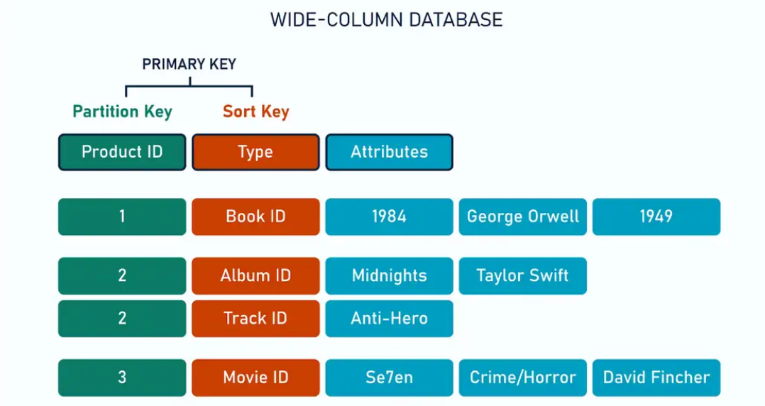
Portioning key parts the cols rows and sort is use to sort the partisioning. Allows massive vertical scalling and to million and billion of rows. Wide-column databases support complex queries like filtering, grouping, and aggregating over massive datasets with millions or billions of rows. Important in the large scale analysis and analytical wali shit. Iot systems and big data analysis.

- Graph DB neo4j, amazon Neptune, janus graph. Data is stored in the form of nodes and edges. Nodes are entites, edges are the relation between them theres also a property storage for special kinda relationships to be stored. Their best feature is the relationship storage we have between the entites.social networks, fraud detections and NLP wali shit.

Multimodal databases are the DBs that supports the storage of Multi-model databases support different ways of storing data (document, key-value, graph, and wide-column) within the same system. They allow applications to store data in the most convenient form, handling only one repository. For example, user data can be kept as documents and relations as graphs. Couchbase, Amazon DynamoDB and Arango DB, Cosmos DB.
Eg. “NETFLIX Multimodal Lakehouse" architecture, leveraging LanceDB to unify, index, and query vast amounts of unstructured, semi-structured, and structured media data. The core of their infrastructure relies on Apache Cassandra for handling massive, distributed write/read loads, along with a proprietary in-memory cache layer called EVCache.

Flexibal databases. Veritical scalling. Big data and flixibal logic. Often handelled in app. Rapid development with changing data models, Massive scalability, High read/write performance and Handling JSON or semi-structured data.

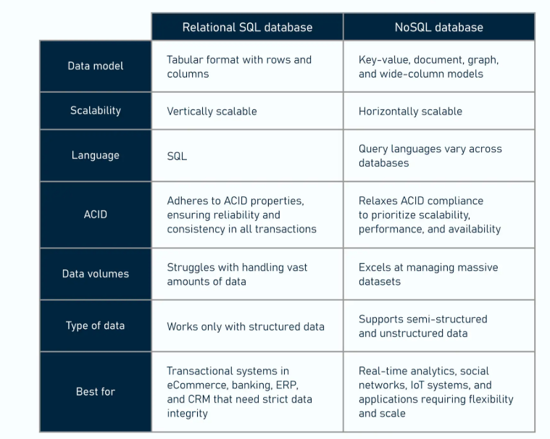
NoSQL databases support horizontal scalability, which means increasing the capacity by adding more servers (or nodes) rather than upgrading the resources of a single server, known as vertical scaling. The ability to distribute workloads across multiple machines is critical for handling massive amounts of data while maintaining acceptable performance. That’s why NoSQL databases are commonly used for big data analytics, IoT (Internet of Things) apps, and content management systems (CMS).
By using the sharading we can horizontally scale the database and then that adds more servers on the systems. Data transformation is also really easy.

Which to use when? SQL vs NOSQL?
- Consider how often you perform read and write operation.
- How often will I have to change the structure. [in SQL need to do the DDL operation and noSQL is different].
- How much of the data is unknown.
- What does the final product look like.
- Multiregional replication from ground up Horizontally scalable.
- No downtime for the schema changes.
Where NOSQL lacks compared to the SQL?
- Complex joins are not supported.
- NO ACID transactions. So lacks the security.
- Ad hoc analytics -> exploring shit you didn’t knew existed.
- SQL is standardised but in the case of the NOSQL every single NoSQL has different language.

Colom dbs have : high throughput and faster R/W ops.

VERICAL SCALLING
Vertical scaling means adding more power to your existing machine - upgrading the hardware itself.
Adding more cores, ssd, RAM better or network cards.
Better cause :
- Simple to implement.
- No distribution complexity.
- Better for simpler applications and usecases.
But:
- Expensive.
- Hard limits
- Downtime for upgrades
- More you scale lower the expected results wali shit.

Horizontal scalling
Instead of making one worker superhuman, you hire more workers and divide the work among them. Unlimited scalling and more workers you add better the results. High fault tolerance, rolling upgrades, geographic distribution, cost effective and no down time to upgrade.
But:
- Complex
- Data consistency challenges
- Network overhead
- Debug is harder

NOSQL AND HORIZONTAL SCALLING
Cassandra - Automatically distributes data across nodes using consistent hashing. Add a node, it rebalances automatically.
MongoDB - Shards collections across multiple servers. Query router figures out which shard(s) to hit.
DynamoDB - AWS handles all the distribution for you. Just keep adding throughput.
These databases sacrifice some SQL features (complex joins, strong consistency) to scale horizontally.

- Sharding and Partitioning -> divides the data across multiple machines.
- Consistent hashing -> smart data distribution infering which server gets which data.
- Reliablity -> data ke kafi sare copies hote hai. There a var c/as replication factor. For Cassandra its of 3.
- No master node.

Why tho?
- No joins data can live anywhere.
- Eventual consistency. Allows parallesism.

Why cannot be SQL horizontally scalled?
They can be scalled…
- ACID compliance rkhna padega. Kafi hard across multiple cores and systems, two phase commits, multi transactions and coordination between nodes.
- Joins across the shards is required. You'd need to either pull data to one place to join it, or redesign your queries entirely.
- You need coordination of storage to store the data and primary key wali shit fckued up hojayegi.
- No build in sharding you need to build it from scratch using some random algos.
- EX youtube and slack do this using Vitess, proxySQL etc.

